# 1.7 Importing , Checking and Working with Data

Dim() 🡪 tells us the dimensions of the table.

Head() 🡪 shows the first 6 rows.

Tail() 🡪 shows the least 6 rows.

Names() 🡪 Shows the names of the data.

# 1.8 Working with Variables and Data

* When we need to extract a variable from a table u need to use $ symbol. (Recommended)

Ex. LungCap$Age

* Or u can use Attach(name of the table) and R will let u use the variable directly.
* Detach(), is used in the oppose case.

Mean() 🡪 calculate the mean.

Class() 🡪 tells u the type of a variable.

Levels() 🡪 tells u the categories stored in that variable.

Summary()

A problem faced me   
<https://stackoverflow.com/questions/48654453/levels-function-returning-null>

# 1.9 Subsetting (Sort/Select) Data in R with Square Brackets

The Idea behind this video is that u can sort the data inside a table according by typing the condition inside the brackets.

Ex.

> femaleOver15 <- CappData[Gender == "female" & Age >15,]

> femaleOver15

Age LungCap Height Gender Smoke

608 18 6.718 66.0 female no

610 19 8.557 66.0 female yes

618 19 8.035 65.5 female yes

619 18 7.246 64.5 female no

620 16 8.161 66.5 female no

622 16 6.709 63.0 female yes

630 17 8.500 62.0 female no

631 16 9.022 67.5 female no

635 16 5.824 62.0 female yes

643 16 6.943 66.0 female no

652 18 6.559 60.0 female no

653 16 6.385 63.0 female yes

# 1.10 Logic Statements (TRUE/FALSE), cbind and rbind Functions

It is like typing a function in Python, but the difference that it will do the logic statement on the variable and store them inside the new variable they u can recruit them from the variable that u just make.

Ex.

> puberty <- Age>15

> puberty[605:608]

[1] FALSE FALSE FALSE TRUE

طيب مثل ما حكينا بما إنه البيانات رح تتسجل بضمن جدول فبإمكاننا إضافة الجدول على الجدول الأصلي في جدول جديد   
مثال

Ex.

> FemSmoke <- Gender == "female" & Smoke == "Yes"

> moreData <- cbind(CappData, FemSmoke)

> moreData[1:5, ]

Age LungCap Height Gender Smoke FemSmoke

1 9 3.124 57.0 female no FALSE

2 8 3.172 67.5 female no FALSE

3 7 3.160 54.5 female no FALSE

4 9 2.674 53.0 male no FALSE

5 9 3.685 57.0 male no FALSE

* U can remove all the data in ur workspace by type list = ls() inside rm() 🡪 rm(list = (ls))

# 1.11 Setting Up Working Directory

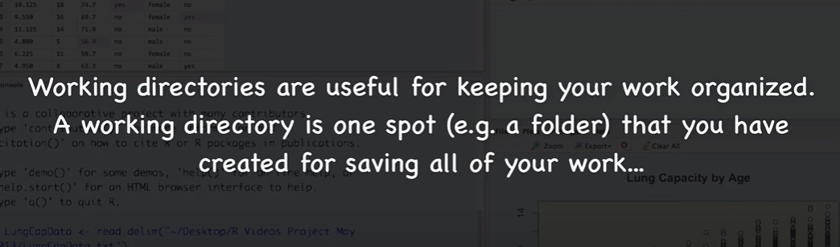

Getwd() 🡪 gets current working directory.

Setwd() 🡪 Sets a new one.

* U can type the full path, or u can use ~ to continue one the same directory.
* *U can do the same from* ***Session*** *menu.*

Save.image(“NameOfTheFile.Rdata”) 🡪 saves an image of current workspace.

* *U can do the same from* ***Session*** *menu.*

Ex. save.image("MondayWorkspace.Rdata")

Load(“NameOfTheFile.Rdata”) 🡪loads previous image of workspace.

* *U can do the same from* ***Session*** *menu.*